BITS PILANI, DUBAI CAMPUS
DUBAI INTERNATIONAL ACADEMIC CITY, DUBAI

FIRST SEMESTER 2023 – 2024
COURSE: CSF303 (Computer Network)
COMPONENT: Tutorial Sheet 3 DATE: 22nd February 2024

- Suppose there is exactly one packet switch between a sending host and the receiving host. Assume that the transmission speed of the links between the sending host & the switch, the switch& the receiving host are R1 and R2 respectively. Assuming that the switch uses store-and forward packet switching, what is the total end-to-end delay to send a packet of length L? Ignore, queuing, propagation and processing delays.

Solution:

At time t0 the sending host begins to transmit. At time t1 = L/R1, the sending host completes transmission and the entire packet is received at the router (no propagation delay).

Because the router has the entire packet at time t1, it can begin to transmit the packet to the receiving host at time t1. At time t2 = t1 + L/R2, the router completes transmission and the entire packet is received at the receiving host (again, no propagation delay).

Thus, the end‐to‐end delay is L/R1 + L/R2.

- Consider an application that transmits data at a steady rate (for example, the sender generates an N-bit unit of data every k time units, where k is small and fixed). Also, when such an application starts, it will continue running for a relatively long period of time. Answer the following questions. Briefly justifying your answer:

  - Would a packet-switched network or a circuit-switched network be more appropriate for this application? Why?
  - Suppose that a packet-switched network is used and the only traffic in this network comes from such applications as described above. Furthermore, assume that the sum of the application data rates is less than the capacities of each and every link. Is some form of congestion control needed? Why?

Sol:
- A circuit-switched network would be well suited to the application, because the application involves long sessions with predictable smooth bandwidth requirements. Since the transmission rate is known and not bursty, bandwidth can be reserved for each application session without significant waste. In addition, the overhead costs of setting up and tearing down connections are amortized over the lengthy duration of a typical application session.
- In the worst case, all the applications simultaneously transmit over one or more network links. However, since each link has sufficient bandwidth to handle the sum of all of the applications' data rates, no congestion (very little queuing) will occur. Given such generous link capacities, the network does not need congestion control mechanisms.

- Consider two hosts, A and B, connected by a single link of rate R bps. Suppose that the two hosts are separated by m meters, and suppose the propagation speed along the link is s meters/sec. Host A is to send a packet of size L bits to Host B.

  - Ignoring processing and queuing delay, obtain an expression for the end-to-end delay.
  - Suppose s=2.5*10^8 meters/sec, L=120 bits, and R=56kbps. Find the distance m so that the propagation delay equals transmission delay.

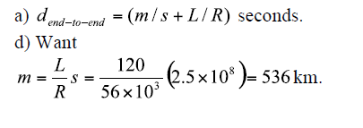

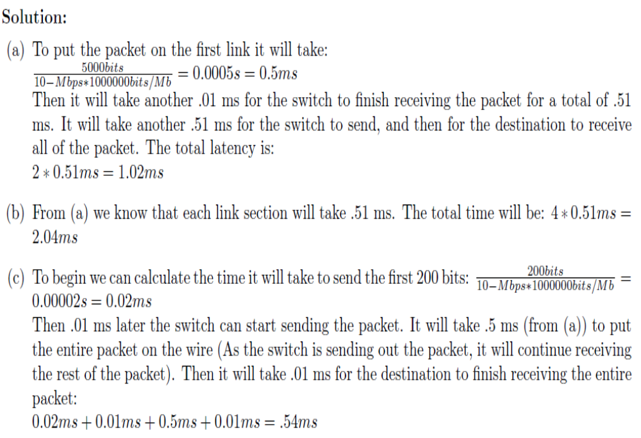
5.

